

**(Affiliated to Tribhuvan University)**

**Advanced Java Programming**

**Basic concepts of Java Programming**

|  |  |
| --- | --- |
|  |  |
|  |  |
|  |  |

**Submitted by:**

Abhinna Ojha, 20788/075

BSc. CSIT - VII

**Submitted to:**

Mr. Krishna Pandey

Department of CSIT

# Data Types and Operations

## Use all the data types and given arithmetic operations.

public class DataOperators

{

public static void main(String[] args)

{

int i1 = 6, i2 = 12;

float f1 = 4, f2 = 5;

double d1 = 3.1, d2 = 1.3;

char c1 = 'b', c2 = 'a';

System.out.println("Addition:");

System.out.println("int:\t\t " + i1 + " + " + i2 + " = " + (i1 + i2));

System.out.println("float:\t\t " + f1 + " + " + f2 + " = " + (f1 + f2));

System.out.println("double:\t\t " + d1 + " + " + f2 + " = " + (d1 + d2));

System.out.println("char:\t\t " + c1 + " + " + c2 + " = " + (c1 + c2));

System.out.println("\nSubtraction:");

System.out.println("int: \t\t" + i1 + " - " + i2 + " = " + (i1 - i2));

System.out.println("float: \t\t" + f1 + " - " + f2 + " = " + (f1 - f2));

System.out.println("double: \t\t" + d1 + " - " + f2 + " = " + (d1 - d2));

System.out.println("char: \t\t" + c1 + " - " + c2 + " = " + (c1 - c2));

System.out.println("\nMultiplication:");

System.out.println("int: \t\t" + i1 + " * " + i2 + " = " + (i1 * i2));

System.out.println("float: \t\t" + f1 + " * " + f2 + " = " + (f1 * f2));

System.out.println("double: \t\t" + d1 + " * " + f2 + " = " + (d1 * d2));

System.out.println("char: \t\t" + c1 + " * " + c2 + " = " + (c1 * c2));

System.out.println("\nDivision:");

System.out.println("int: \t\t" + i1 + " / " + i2 + " = " + (i1 / i2));

System.out.println("float: \t\t" + f1 + " / " + f2 + " = " + (f1 / f2));

System.out.println("double: \t\t" + d1 + " / " + f2 + " = " + (d1 / d2));

System.out.println("char: \t\t" + c1 + " / " + c2 + " = " + (c1 / c2));

i1++; f1++; d1++; c1++;

System.out.println("\nIncrement:");

System.out.println("int: \t\t" + i1 + "++ = " + i1);

System.out.println("float: \t\t" + f1 + "++ = " + f1);

System.out.println("double: \t\t" + d1 + "++ = " + d1);

System.out.println("char: \t\t" + c1 + "++ = " + c1);

i1--; f1--; d1--; c1--;

System.out.println("\nDecrement:");

System.out.println("int: \t\t" + i1 + "-- = " + i1);

System.out.println("float: \t\t" + f1 + "-- = " + f1);

System.out.println("double: \t\t" + d1 + "-- = " + d1);

System.out.println("char: \t\t" + c1 + "-- = " + c1);

}

}

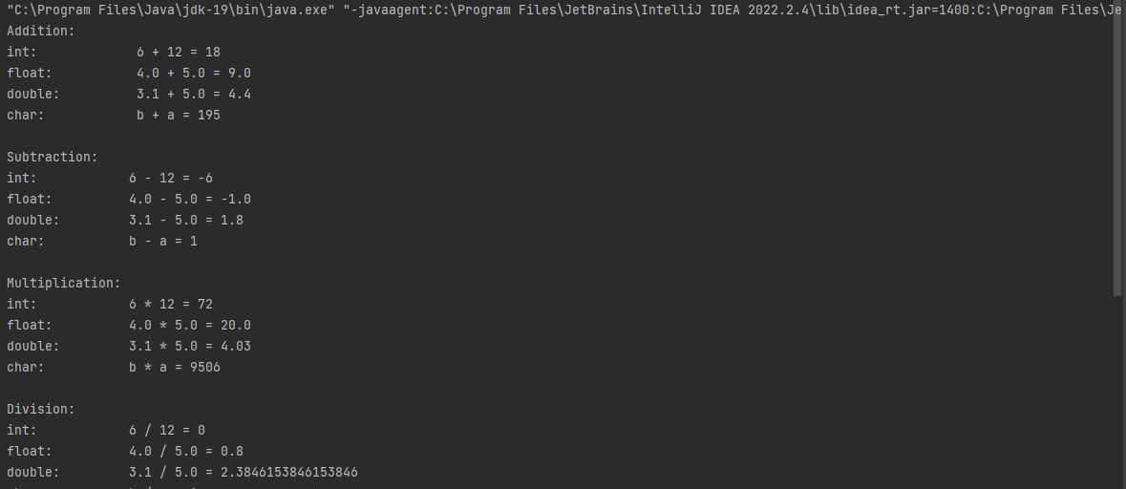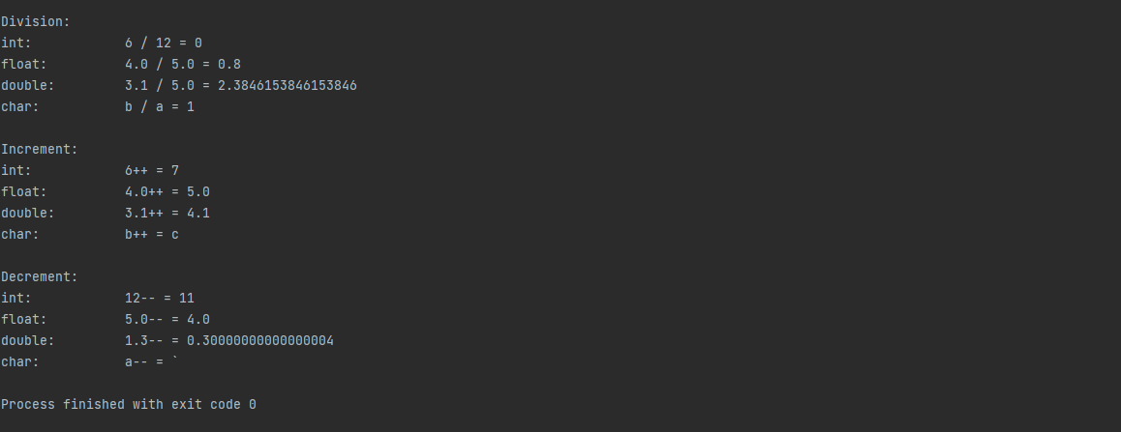

## Perform all the arithmetic operations given in the table.

public class Operators

{

public static void main(String[] args)

{

int a = 1, b = 2;

System.out.println("Addition, a + b = " + a + " + " + b + " = " + (a + b));

System.out.println("Subtraction, a - b = " + a + " - " + b + " = " + (a - b));

System.out.println("Multiplication, a * b = " + a + " * " + b + " = " + (a * b));

System.out.println("Division, a / b = " + a + " / " + b + " = " + (a / b));

System.out.print("Increment, a++ = " + a + "++ => " + "a = " + a + " + 1" + " = ");

a++;

System.out.print(a);

System.out.print("\nDecrement, b-- = " + b + "-- => " + "b = " + b + " - 1" + " = ");

b--;

System.out.print(b);

}

}

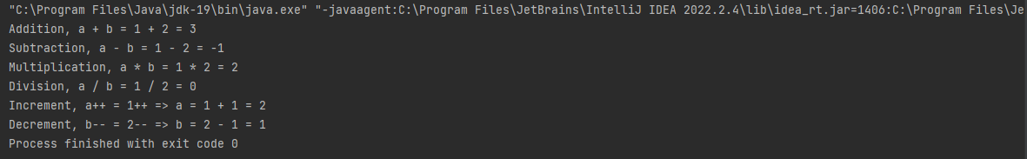

# if Condition

## Program to check if a candidate is eligible for voting or not.

public class VoterCheck

{

public static void main(String[] args)

{

int age = 18;

if(age < 18)

{

System.out.println("Not eligible to vote");

}

else

{

System.out.println("Eligible to vote");

}

}

}



## Program to check if the number is positive or negative.

public class PositiveNegative

{

public static void main(String[] args)

{

int n = 1;

if ( n < 0)

{

System.out.println("less than zero so negative");

}

else

{

System.out.println("greater than zero so positive");

}

}

}



## Program to check whether if a number is positive, zero or negative.

public class PositiveNegativeZero

{

public static void main(String[] args)

{

int n = 1;

if ( n < 0)

{

System.out.println("less than zero so negative");

}

else if ( n > 0)

{

System.out.println("greater than zero so positive");

}

else

{

System.out.println("zero");

}

}

}



## Program to find largest of two numbers.

public class LargerOf2Num

{

public static void main(String[] args)

{

int a = 13, b = 17;

if(a < b)

{

System.out.println("b = " + b + " is larger than a =" + a);

}

else if(a > b)

{

System.out.println("a = " + a + " is larger than b =" + b);

}

else

{

System.out.println("a = b = " + a);

}

}

}



## Program to check given number is even or odd.

public class EvenOdd

{

public static void main(String[] args)

{

int n = 5;

if (n % 2 == 0)

{

System.out.println("n = " + n + " is even");

}

else

{

System.out.println("n = " + n + " is odd");

}

}

}



# for loop

## Program to print 10 even numbers and 10 odd numbers.

public class OddEvenDisplay

{

public static void main(String[] args)

{

int i, os = 0, es = 0, o = 1, e = 2;

System.out.println("\t\tOdd\t\t\tEven");

for (i = 0; i < 10; i++)

{

os = os + o;

es = es + e;

System.out.println((i + 1) + ".\t\t " + o + "\t\t\t " + e);

o += 2;

e += 2;

}

System.out.println("sum:\t " + os + "\t\t " + es);

}

}

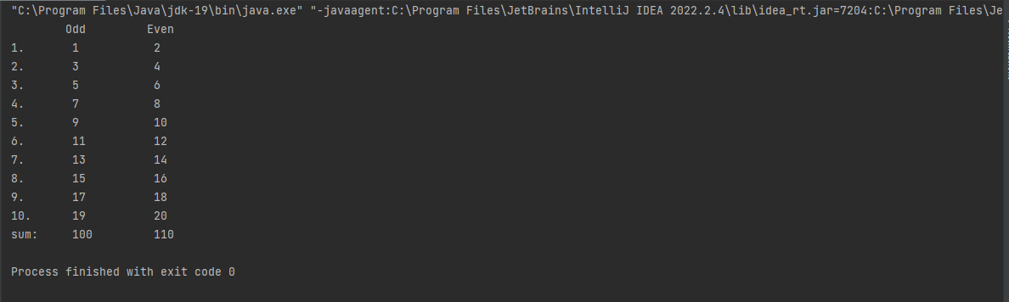

## Program to find factorial of a number.

public class Factorial

{

public static void main(String[] args)

{

int n = 13, f = 1;

for (int i = 1; i <= n; i++)

{

f *= i;

}

System.out.println("Factorial of " + n + " is " + f);

}

}



## Program to generate tables of 10.

public class TablesOf

{

public static void main(String[] args)

{

int n = 13;

for (int i = 0; i <= 10; i++)

{

System.out.println(n + " x " + i + " = " + (n * i));

}

}

}

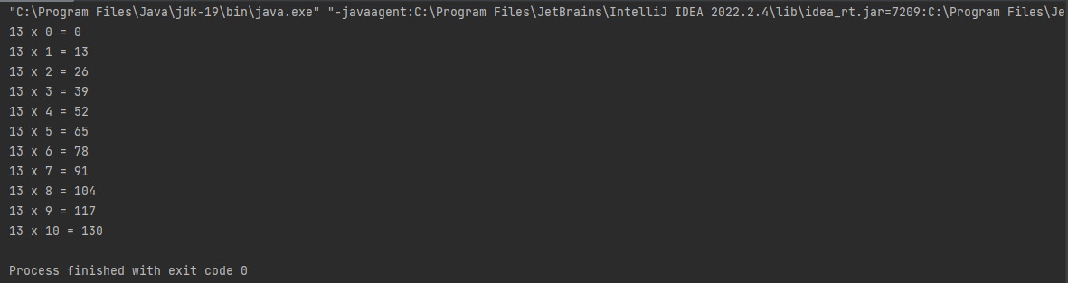

## Program to add the digits of a number.

public class AddDigits

{

public static void main(String[] args)

{

int n = 659, sum = 0;

for (int i = n; i != 0; i /= 10)

{

int x = i % 10;

sum += x;

}

System.out.println("The sum of digits of " + n + " is " + sum);

}

}



## Program to reverse the digits of a number.

public class ReverseDigits

{

public static void main(String[] args)

{

int n = 659, rev = 0;

for (int i = n; i != 0; i /= 10)

{

int x = i % 10;

rev = rev * 10 + x;

}

System.out.println("The reverse of digits of " + n + " is " + rev);

}

}



## Program to generate 10 Fibonacci numbers.

public class Fibonacci

{

public static void main(String[] args)

{

int a = 0, b = 1, c;

for (int i = 0; i < 10; i++)

{

c = a + b;

System.out.println(c);

a = b;

b = c;

}

}

}

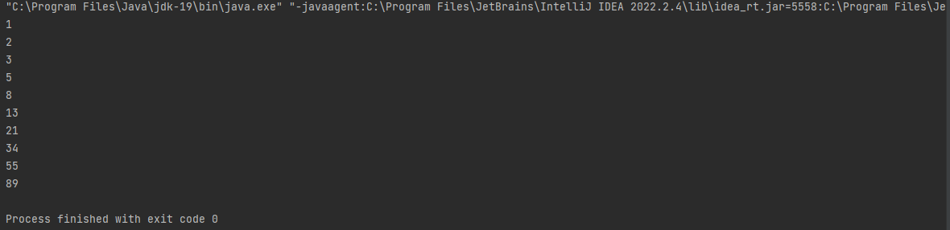

# while loop

## Program to print 10 even numbers and 10 odd numbers.

public class OddEvenDisplay {

public static void main(String[] args) {

int i = 0, os = 0, es = 0, o = 1, e = 2;

System.out.println("\t\tOdd\t\t\tEven");

while (i < 10)

{

os = os + o;

es = es + e;

System.out.println((i + 1) + ".\t\t " + o + "\t\t\t " + e);

o += 2;

e += 2;

i++;

}

System.out.println("sum:\t " + os + "\t\t " + es);

}

}

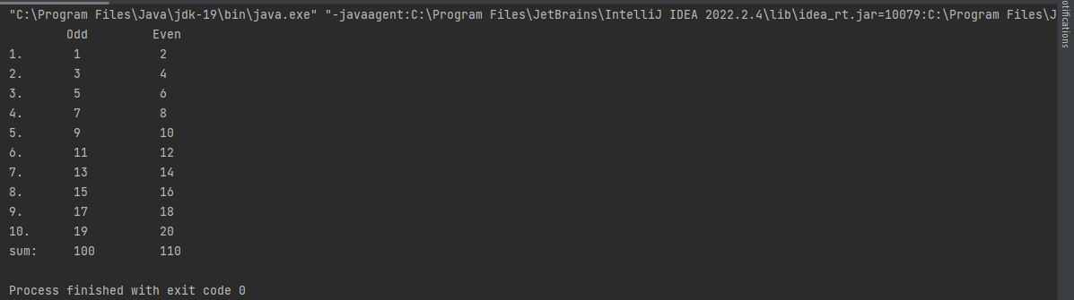

## Program to find factorial of a number.

public class Factorial

{

public static void main(String[] args)

{

int n = 9, f = 1, i = 1;

while (i <= n)

{

f *= i;

i++;

}

System.out.println("Factorial of " + n + " is " + f);

}

}



## Program to generate tables of 10.

public class TablesOf

{

public static void main(String[] args)

{

int n = 17, i = 0;

while (i <= 10)

{

System.out.println(n + " x " + i + " = " + (n * i));

i++;

}

}

}

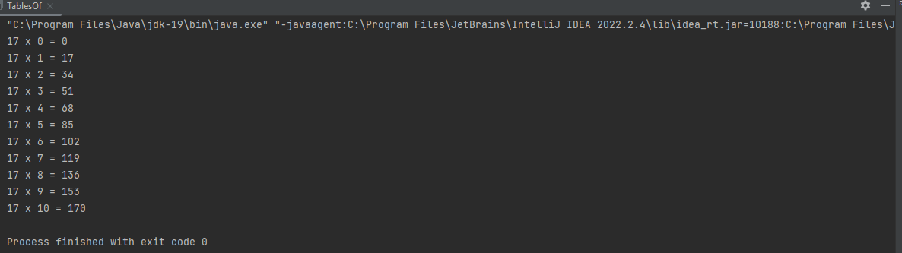

## Program to add the digits of a number.

public class AddDigits

{

public static void main(String[] args)

{

int n = 619, sum = 0, i = n;

while (i != 0)

{

int x = i % 10;

sum += x;

i /= 10;

}

System.out.println("The sum of digits of " + n + " is " + sum);

}

}



## Program to reverse the digits of a number.

public class ReverseDigits

{

public static void main(String[] args)

{

int n = 6059, rev = 0, i = n;

while (i != 0)

{

int x = i % 10;

rev = rev * 10 + x;

i /= 10;

}

System.out.println("The reverse of digits of " + n + " is " + rev);

}

}



## Program to generate 10 Fibonacci numbers.

public class Fibonacci

{

public static void main(String[] args)

{

int a = 0, b = 1, c, i = 0;

while (i < 10)

{

c = a + b;

System.out.println(c);

a = b;

b = c;

i++;

}

}

}

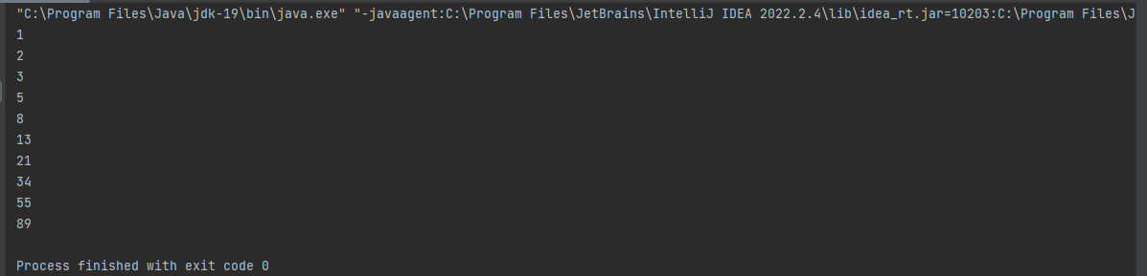

# do while loop

## Program to print 10 even numbers and 10 odd numbers.

public class OddEvenDisplay

{

public static void main(String[] args)

{

int i = 0, os = 0, es = 0, o = 1, e = 2;

System.out.println("\t\tOdd\t\t\tEven");

do

{

os = os + o;

es = es + e;

System.out.println((i + 1) + ".\t\t " + o + "\t\t\t " + e);

o += 2;

e += 2;

i++;

}while (i < 10);

System.out.println("sum:\t " + os + "\t\t " + es);

}

}

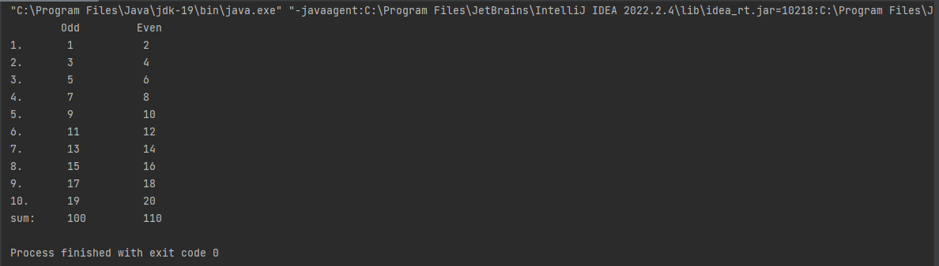

## Program to find factorial of a number.

public class Factorial

{

public static void main(String[] args)

{

int n = 6, f = 1, i = 1;

do {

f *= i;

i++;

}while (i <= n);

System.out.println("Factorial of " + n + " is " + f);

}

}



## Program to generate tables of 10.

public class TablesOf

{

public static void main(String[] args)

{

int n = 59, i = 0;

do

{

System.out.println(n + " x " + i + " = " + (n * i));

i++;

}while (i <= 10);

}

}

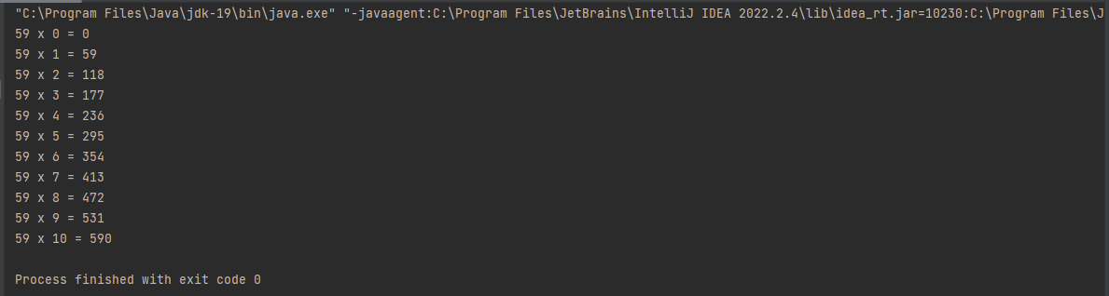

## Program to add the digits of a number.

public class AddDigits

{

public static void main(String[] args)

{

int n = 666, sum = 0, i = n;

do

{

int x = i % 10;

sum += x;

i /= 10;

}while (i != 0);

System.out.println("The sum of digits of " + n + " is " + sum);

}

}



## Program to reverse the digits of a number.

public class ReverseDigits

{

public static void main(String[] args)

{

int n = 1317, rev = 0, i = n;

do

{

int x = i % 10;

rev = rev * 10 + x;

i /= 10;

}while (i != 0);

System.out.println("The reverse of digits of " + n + " is " + rev);

}

}



## Program to generate 10 Fibonacci numbers.

public class Fibonacci

{

public static void main(String[] args)

{

int a = 0, b = 1, c, i = 0;

do

{

c = a + b;

System.out.println(c);

a = b;

b = c;

i++;

}while (i < 10);

}

}

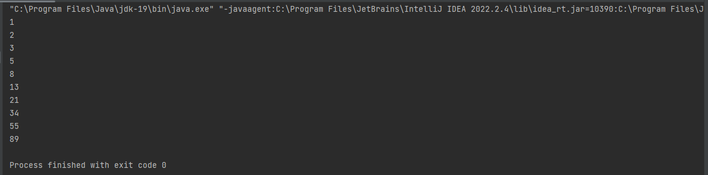

# Case studies

## Case 1, Amusement Park

public class Case1AmusementPark {

public static void main(String[] args) {

int price = 400, number = 15;

int amount, discount;

if (number > 10) {

amount = price * number;

discount = amount * 10 / 100;

amount = amount - discount;

} else {

amount = price * number;

discount = 0;

}

System.out.println("The total amount for " + number + " tickets at rate of Rs." +

price + " per ticket is " + amount);

System.out.println("You recieved Rs." + discount + " as discount");

}

}

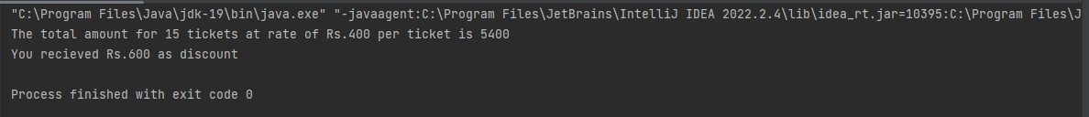

## Case 2, Theatre

public class Case2Theatre {

public static void main(String[] args) {

String category = "silver";

int price = 0;

if(category.equals("gold")) {

price = 200;

} else if (category.equals("silver")) {

price = 150;

}

System.out.println("The category chosen is " + category + " and price is Rs. " + price);

}

}

